Ian Reads to His Family

Ian wanted to read a book to his family. He took the book to Mom. “Mom, can I read this book to you?” Ian asked. “I would love that,” Mom said. “But I need to make dinner. Maybe Dad would like a story.” She went back to stirring a pot of soup. Ian looked for Dad. Dad was sitting at his desk. “Dad, can I read this book to you?” Ian asked. “I would love that,” Dad said. “But I need to hop on a call for work. Maybe Amy would like a story.” He turned back to his desk and picked up the phone. Ian looked for his little sister, Amy.

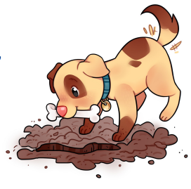

Amy was stacking blocks in her bedroom. “Amy, can I read this book to you?” Ian asked. Amy pulled the book from Ian. She bit it. “No, Amy,” Ian said. He took the book back. “Books are for reading, not eating.” Amy looked around. “Dog?” She toddled away. “Yes, maybe Sir Wags-a-Lot will want a story,” Ian said. Ian looked for his dog. Sir Wags-a-Lot was digging a hole in the garden outside. “Sir Wags-a-Lot, can I read this book to you?” Ian asked. Sir Wags-a-Lot barked. He went back to burying his bone. “I’ll just read to myself,” Ian said, going inside to the den. He sat down and read his book aloud. Soon, Sir Wags-a-Lot came in and sat beside Ian. Amy flopped down next to the dog. “My meeting is done,” Dad said, joining them. “I can’t wait to hear your story.” “Wait for me!” Mom said. She put the lid on her pot and hurried over. Ian read to his family. It was fun reading alone, but it was more fun sharing the story with his family.